SOMESHWARAN K

192121115

20/03/2023

R PROGRAMMING

ASSIGNMENT 1

1. Consider two vectors, x, y x=c(4,6,5,7,10,9,4,15) y=c(0,10,1,8,2,3,4,1) What is the value of:

x*y

2Consider two vectors, a, b

a=c (1,2,4,5,6) b=c(3,2,4,1,9) What is the value of: cbind(a,b)

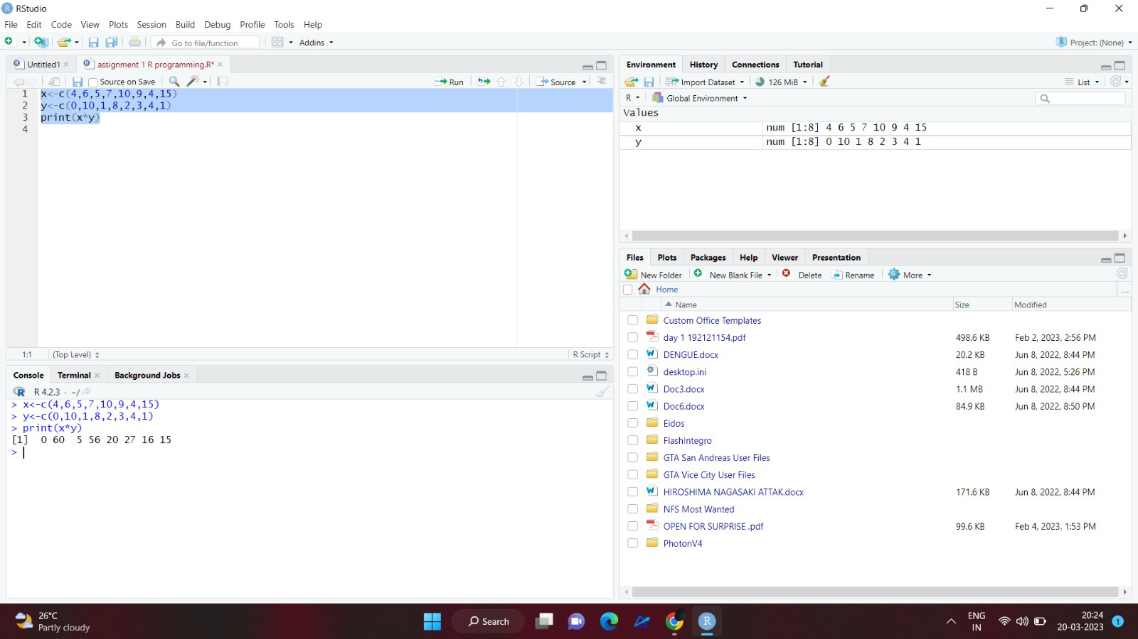

OUTPUT:

> x=c(4,6,5,7,10,9,4,15)

> y=c(0,10,1,8,2,3,4,1)

> x*y

[1] 0 60 5 56 20 27 16 15

>.

2. Vector v is c(1,2,3,4) and list x is list(5:8), what is the output of v*x[1]?

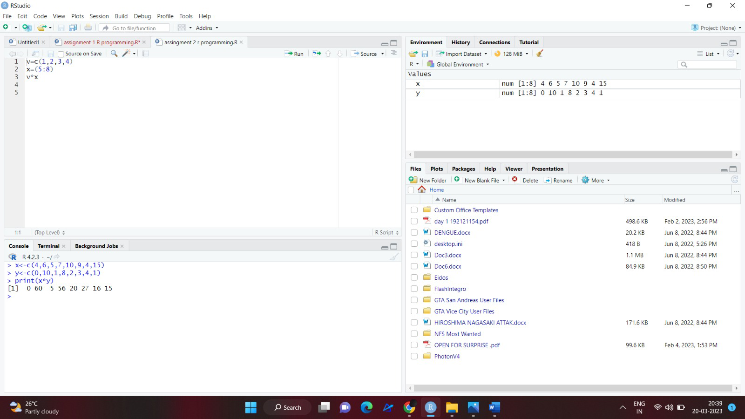

OUTPUT:

>X<-C(4,6,5,7,10,9,4,15)

>Y<-C(0,10,1,8,2,3,4,1)

>Print(x*y)

[1] 0 60 5 56 20 27 16 15

>

3. Vector v is c(1,2,3,4) and list x is list(5:8), what is the output of v*x[[1]]?

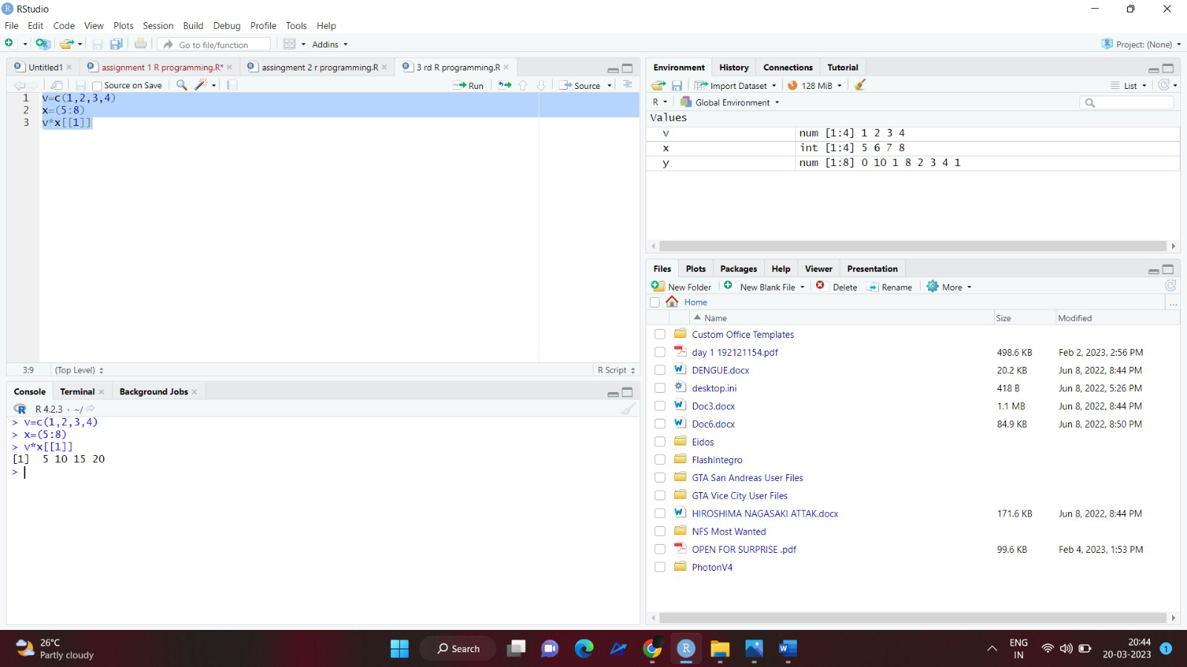

OUTPUT:

> v=c(1,2,3,4)

> x=(5:8)

> v*x[[1]]

[1] 5 10 15 20

4. X is the vector c(5,9.2,3,8.51,NA), What is the output of mean(x)?

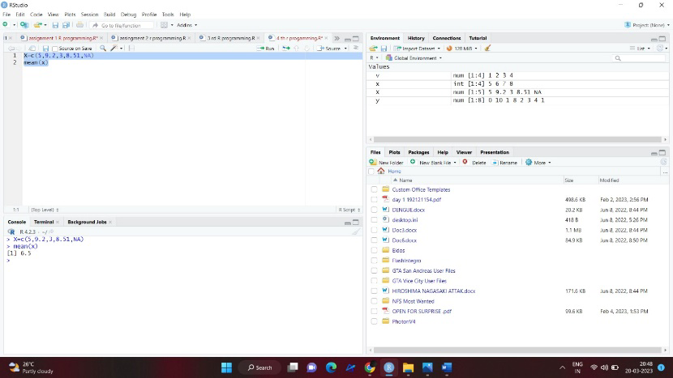

OUTPUT:

> X=c(5,9.2,3,8.51,NA)

> mean(x)

[1] 6.5

5. Give a function in R that replaces all missing values of a vector x with the sum of elements

of that vector?

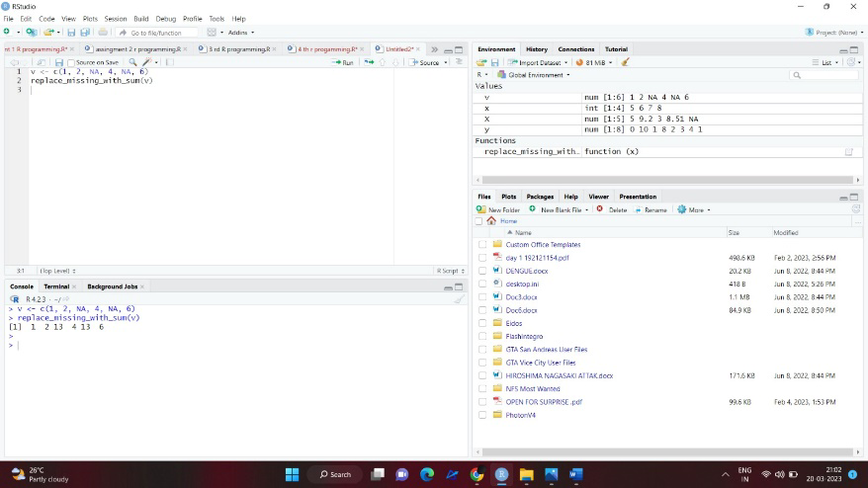

OUTPUT:

> v <- c(1, 2, NA, 4, NA, 6)

> replace_missing_with_sum(v)

[1] 1 2 13 4 13 6

>